Bidding Process

Audeh Aklouk, John Fernandez, Anna Jenkins, Julian Matthews, Jayshawn Mercedes

Project Plan

Meeting Makers is an organization that provides services to assist companies or organizations in organizing conferences and meetings in a variety of cities across the country. The organization is relatively small with 10 project managers, 7 office staff personnel, and 1 graphic designer. The employees have various responsibilities including handling participant registration, fielding questions from attendees, securing meeting spaces and hotel rooms, and planning extracurricular activities. The organization gathers information regarding the city, dates, anticipated number of attendees, price range, and external activities to arrange a bid that they propose to clients. They calculate estimated quotes and present them to clients which is essential to their success. The project bids include hotel information, registration, brochures, and extracurricular activities.

Meeting Makers relies on information technology to carry out the essential parts of the organization. They store data in an Access system. This database is located on one PC, so the staff and project managers must alternate usage of the PC to accomplish their work. The database holds specific information about the conference, attendees, and hotel.

Meeting Makers has several issues with their information system that their management has recognized. Grouping the issues into responsibility issues and inefficiency issues seems to be a logical approach. The first responsibility issue is penalty charges. Project managers continue to forget to cancel a booking when a client no longer has an interest in holding an event. The hotel that planned to host the event then penalizes Meeting Makers for not notifying or updating them of the event’s current status. This issue causes Meeting Makers to not only lose money from paying a fee, but also lose future reservations at certain hotels because of the organization’s lack of communication and dependability. The second responsibility issue is inaccuracy of data. According to Meeting Makers management, the organization lost 15 bids due to sloppiness. These bids included inadequate hotels and an inaccurate quote due to a miscalculation of the number of participants. This may have been due to employees altering data so it could be stored correctly in the software program. This issue likely contributes to the decline in the percentage of repeat customers that Marge estimates will decrease from the current 75% to 60%. Lastly, the third responsibility issue is lateness. Deadlines are not consistently being met, which doesn’t make a good impression on clients.

The main inefficiency issue is the lack of technology and computer software training. The employees do not have proficient skills in the current software programs they utilize, and they also do not have sufficient training in all of the software programs. Likely due to the lack of training, important information is not saved electronically or sent electronically. Additionally, the graphic designer doesn’t record any information anywhere, so his colleagues have a hard time preparing bids when he is away from work. This can significantly slow down the amount of time it takes to develop a bid.

By identifying the issues of the current information system, we can determine whether a new information system is necessary. In this case, a new information system could increase the quality and efficiency of Meeting Makers employees. Our team plans to identify, analyze, and deliver the system requirements, process analysis, data analysis, user interface design, and presentation of the Bidding Process Information System.

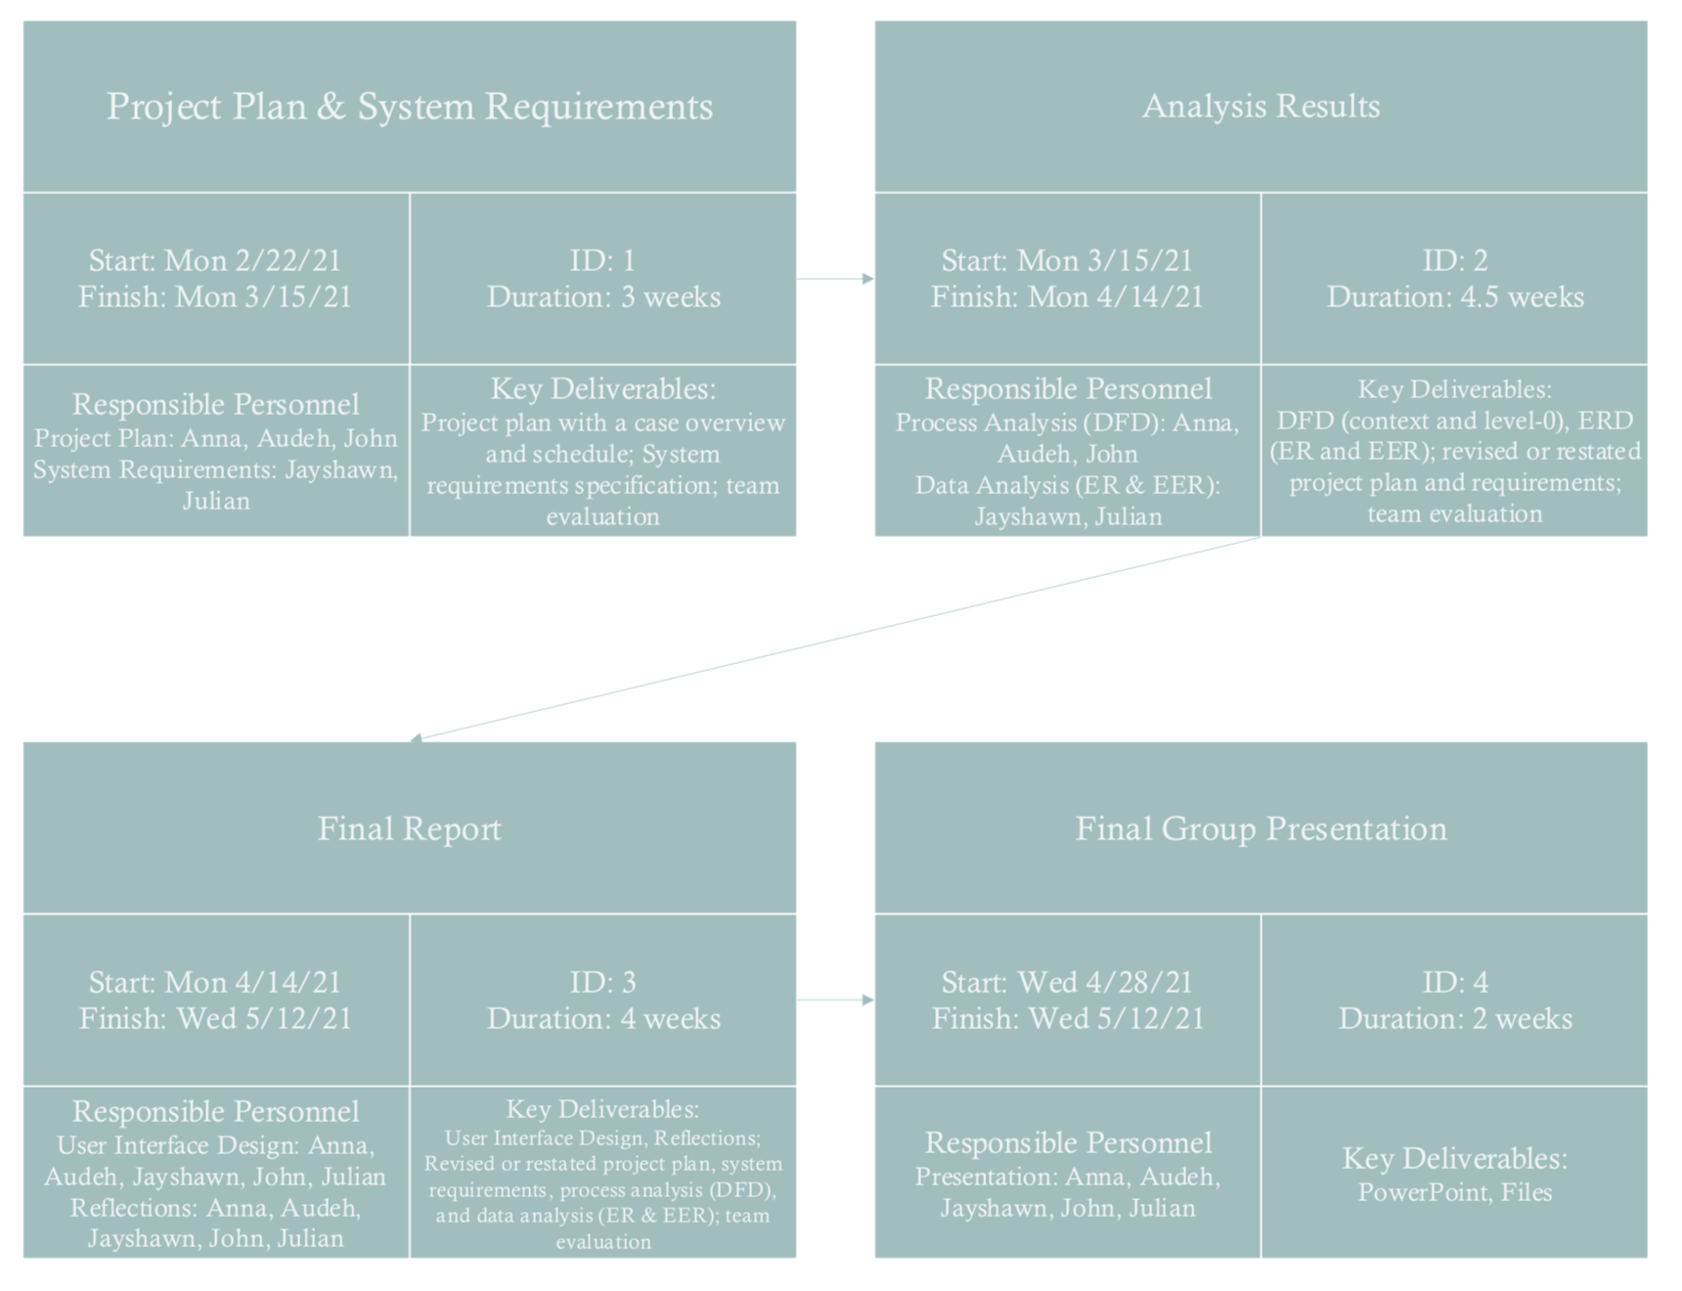

System Requirements Specification

Meeting Makers is a company that specializes in creating, organizing, and coordinating conferences and meetings. Their current system consists of multiple steps and processes. Meeting Makers gathers necessary resources to prepare a bid. The current bidding process estimates the cost of all services proposed in the bid. This includes mail registration, brochure cost, reservation cost, staff, and miscellaneous costs. Meeting Makers also sends staff to assist in running the conferences. Our team will focus on the bidding process and exclude the management part of the conference. This is because the back bone of Meeting Makers is securing hotels and determining costs. Meeting Makers will not manage anything if there is no bid in the first place.

The first functional requirement for Meeting Makers consists of calculating the total number of attendees. This is important because the number of attendees allows Meeting Makers to gauge how much space they need for the conference/meeting. Estimating the number of attendees is a necessary first step for determining the cost of the main requirements of the bidding process. Another reason determining the number of attendees is vital for the system is because this number will not only determine the cost of the hotel but also the cost of all the other expenses for the conference/meeting.

The next functional requirement is determining the cost of the mail registration. This relates to the number of attendees because this is just for sending out the information for the event. This also has a part in the bidding process because it factors into the total cost.

The next functional requirement is determining the cost of the brochure. The creation of the brochure is dependent on the graphic designer and the design is based off of the customer’s request. Also depending on the conference size and scale, the number of pages and attendees will be reflected in the price.

The next functional requirement is the cost of the hotel reservation. This requirement is one of the most important steps in the bidding process. This is because without a bid, there is nothing else that Meeting Makers can do. To place a bid, the hotel must talk to the client about their wants and needs for the event they want to host. After this has been determined, Meeting Makers will place holds on a few hotels to secure a location.

The next functional requirement is the cost for the staff to work at the event. The cost of the staff here is not necessarily a focus point for the bidding process, but it still has a significant impact on the total cost. This is a functional requirement because Meeting Makers needs staff to help run, maintain, and organize the actual event at the hotel. The number of staff is determined by the size of the event and by the client. This may not be the most important functional requirement but it is still very necessary for the bidding process.

The next set of requirements discussed will be nonfunctional requirements. Meaning they have importance, but overall the system could survive without them. These requirements still have an important role in the current information system for Meeting Makers.

The first non-functional requirement is the network and file sharing system. Meeting Makers currently stores all of their data on one computer inside of the company. This causes problems because having only one computer allows fewer people to accomplish important tasks at the same time. Acquiring multiple laptops or computers for Meeting Makers will greatly improve the efficiency and productivity of the company. Having multiple computers can allow file sharing between the employees and increased access to information they need to do their job.

The next non-functional requirement is making sure all the devices within the company use the same software. This is important because using different types and versions of software can cause confusion and turmoil. This is because when all the workers use different software, it becomes very difficult to share files and data within the company. This is why having one software across all devices is a non-functional requirement.

The next non-functional requirement is the database that holds hotel and customer information. This requirement creates a lot of business opportunities for Meeting Makers. Having a database helps keep a record of all of the clients who go to Meeting Makers to pay for their services. Notes on customers' experiences, ratings, and reviews are all recorded in the database for reference. That information stays in the database and allows Meeting Makers to see if their client liked their services or not, and whether they need to improve and change things for the future. This also improves customers relations because having this record allows Meeting Makers to improve and increase the number of repeat customers.

The last non-functional requirement is a list of possible extracurricular activities. This part of the organization’s services is vital to the customer because this is a big part of why and if they would pay Meeting Makers for their services again in the future. When clients arrive in the city of the conference, they may want to spend time away from the hotel. Meeting Makers provides a list of extracurricular activities for clients to participate in while they visit the city. Meeting Makers will also provide the costs for all of the activities so the clients can decide what they may be interested in doing. This improves the Meeting Makers relationships with customers and can impact the number of repeat customers.

**Interaction Worksheet**

(This form will be put on the class website for you to download and use directly)

|  |  |  |  |  |  |  |
| --- | --- | --- | --- | --- | --- | --- |
| **Date** | **Other Party** | **Communication** | **Apprx. Length** | **Topic** | **Major Decision** | **Other Notes** |
| 2/22/21 | All present | Zoom | 15 minutes | -Meeting Times  -Our Main case | -Meetings on Tuesday at 7:00pm and Friday 1:00pm (For now)  - Decided to go with Case Meeting Makers |  |
| 2/23/21 | All present | Zoom | 15 minutes | Discussing the project requirements | Finish reading the case and project objectives by next meeting |  |
| 2/28/21 | All present | Zoom | 45 minutes | -Discussing Case  -Assigning tasks to group members | -Summarize notes into one Doc  -Find out key deliverables and requirements for our IS  - brush up on Class Vocabulary |  |
| 3/2/21 | All present | zoom | 15 minutes | -Reviewing case and assignment guidelines | -Schedule meeting with professor for guidance and review |  |
| 3/7/21 | All present | Zoom | 1.5 hours | -Discussing key objectives and deliverables | -Company needs to update software  -Further training of employees in required  -Provide interface for customers to schedule appointments (website) |  |
| 3/14/21 | All present | Zoom | 30 min | -Checking project objectives before submission | -Continue finishing up the last details of the IS system  -Synthesize and finish tomorrow morning |  |
| 3/15/21 | All present | Zoom | 30 min | -Final check |  |  |